Introduction of azure monitor

Azure Monitor – Features/Capabilities

Working with Basic Log Queries

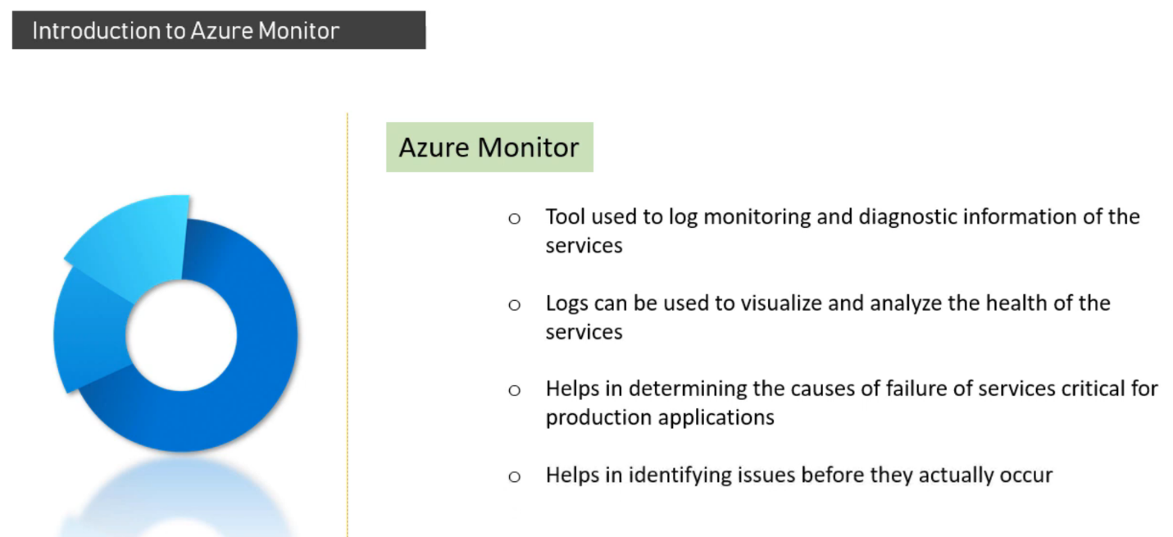

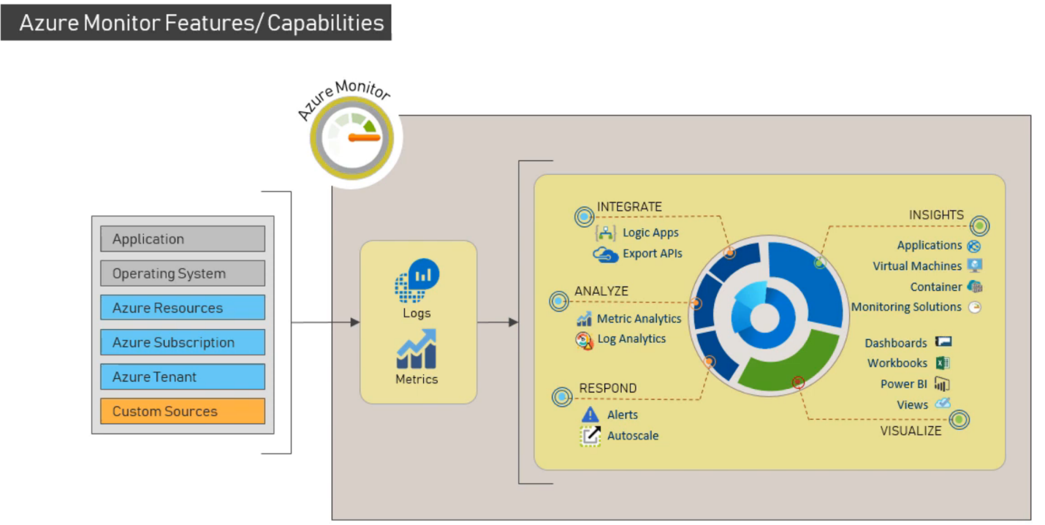

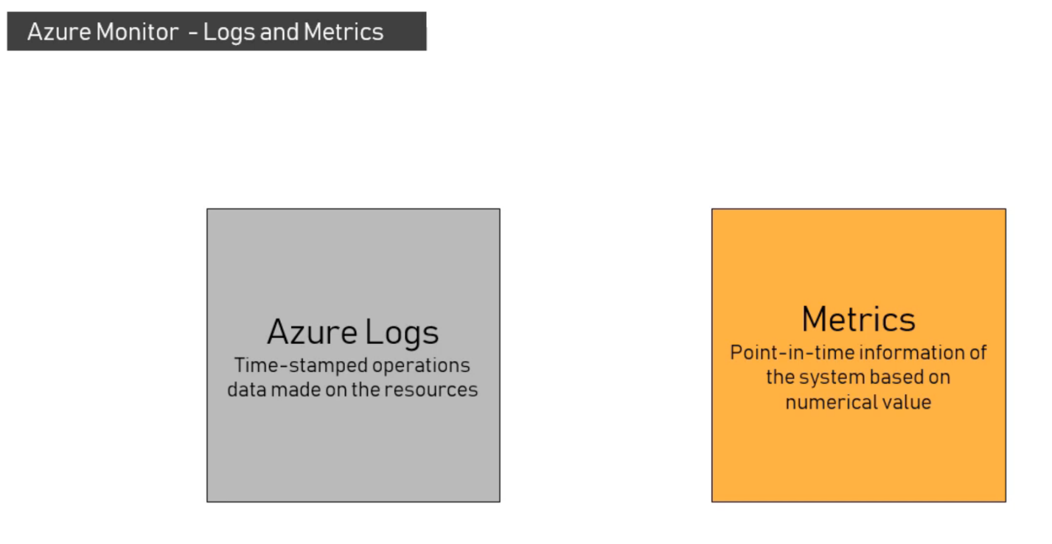

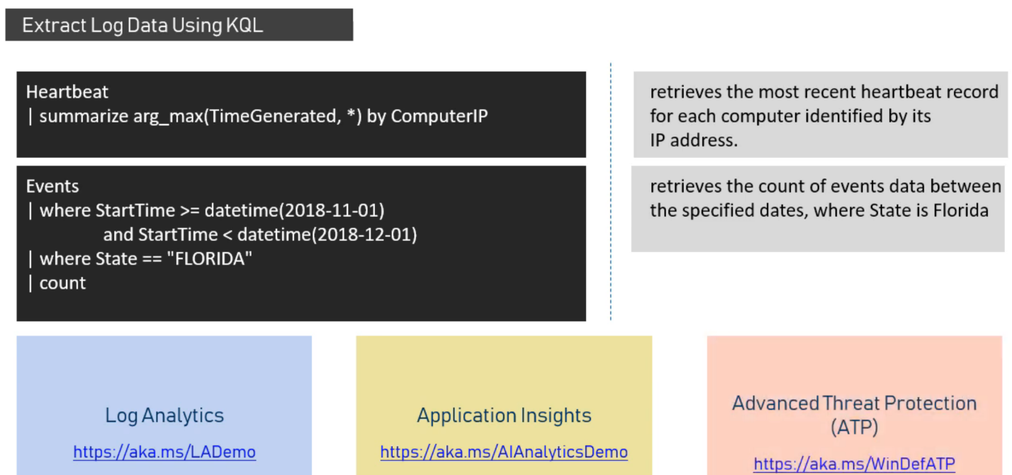

**Monitoring:**

1. Overview
2. Activity logs
3. Alerts
4. Metrics
5. Logs

**Insights:**

1. Applications
2. Virtual machine
3. Storage accounts
4. Containers
5. Networks
6. SQL
7. Azure Consume DB
8. Key vaults
9. Azure Cache for Redis
10. Log analytics workspace
11. Services Bus

Services:

1. Compute
2. Networking
3. Storage
4. Database
5. Analytics
6. Security
7. Monitor
8. Integration
9. Workloads

Key-vault creation

Permission model

Azure role-based access control

Networking